Bryan Jacobson Memorial Scholarship Application
Deadline: May 1st, 2024
(Return this application to Mr. Schafer)

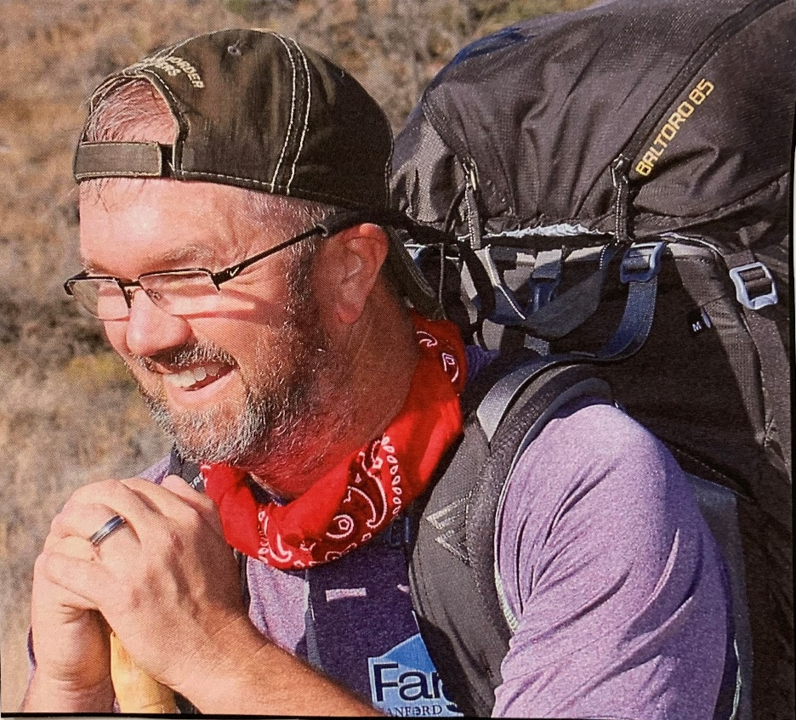

Eligibility:
- Student must be a 2024 graduate of Clearbrook-Gonvick School
- Student must be reliable and responsible
- Planning to attend a post-secondary institution/college
- Preference will be given to a student who can see themselves eventually returning to the Clearbrook community to reside

Name: |  | Major Area of Study:
Date: |  | School Planning to Attend:
Phone Number: |  | Current GPA:
Personal Email:

School Involvement:
______________________________________________________________________________________________________________________________________________________________________________________________________________________________________________________________________________________________________________________________________________________________________________________________________________________________________________________________________________________________________________________________

Future Plans:
______________________________________________________________________________________________________________________________________________________________________________________________________________________________________________________________________________________________________________________________________________________________________________________________________________________________________________________________________________________________________________________________
Community Service:
______________________________________________________________________________________________________________________________________________________________________________________________________________________________________________________________________________________________________________________________________________________________________________________________________________________________________________________________________________________________________________________________

Work Experience:
______________________________________________________________________________________________________________________________________________________________________________________________________________________________________________________________________________________________________________________________________________________________________________________________________________________________________________________________________________________________________________________________

Additional information about yourself you would like to share:
______________________________________________________________________________________________________________________________________________________________________________________________________________________________________________________________________________________________________________________________________________________________________________________________________________________________________________________________________________________________________________________________

